Title: | Window Lifter

History
Issue status  (Index) | Maturity/Date  (draft/invalid/valid)  (dd-mmm-yyyy) | Author  Department | Check/Release  Department | Description
1.0 | 06-22-15 | David Rosales | David Rosales | Creation of the document
2.0 | 07-21-15 | David Rosales  Diego Flores |  | Edition of DSD Template
3.0 | 07-27-15 | David Rosales Diego Flores | Kevin Castellanos Misael Alvarez | Correction of diagrams.
4.0 | 07-28-15 | David Rosales Diego Flores | Kevin Castellanos Misael Alvarez | Final review corrections

Table of Contents
1 Purpose 3
2 Definitions and abbreviations 3
3 Realization constraints and targets 3
4 SW Conceptual design 4

1 Use Case Diagram ……………………………………………………………………………………… 4

4.2 Component Diagram …………………………………………………………………………………. 5

4.3 Design Diagram ……………………………………………………………………………………….. 6

4.4 Sequence Diagram……………………………………………………………………………………..7

5 SW Component internal breakdown 8
5.1 Functional Decomposition 9
5.2 Function void STATE_MACHINE(void) 10
5.3 Function Idle_Func () 11
5.4 Function T_UBYTE Auto_Open_Func () 12
5.5 Function T_UBYTE Manual_Open_Func () 12
5.6 Function T_UBYTE Auto_Close_Func () 13
5.7 Function T_UBYTE Manual_Close_Func () 14
5.8 Function T_UBYTE Antipinch_Func () 15
5.9 Function opening_func () 16
5.10 Function closing_func () 16
5.11 Function main () 17

Purpose
The purpose of this document is to design the functional car window movements electronically.

This window will have 2 possible movements, Open and Close. These movements will also have two different behaviors each depending on the time the button is pressed:
Automatic movement will be executed once the button is pressed less than 500 ms.
Manual movement will be executed once the button is pressed more than 500ms and keeps being pressed.
This window will include a special feature called AntiPinch Function, once the window detects an object when the window is closing, this function will open the window automatically and will ignore any other button during 5 seconds. This will prevent accidents when the user has an object or a body part blocking the window closing movement.

Definitions and abbreviations
Definitions
Antipinch. Feature that prevents pinching or accidents to the user when the window is closing.
Abbreviations
PIT | Programmable Interrupt Timer
GPIO | General Purpose Input/Output
WL | Window Lifter

References
N° | Document name | Reference
1 | Window lifter requirements
2 | Traceability Matrix Template
3 | SW C Code Review Tamplate
4 | Test Plan

Realization constraints and targets

To create a robust and portable system, capable of functioning in any kind of event.

SW Conceptual design

- Use Cases Diagram
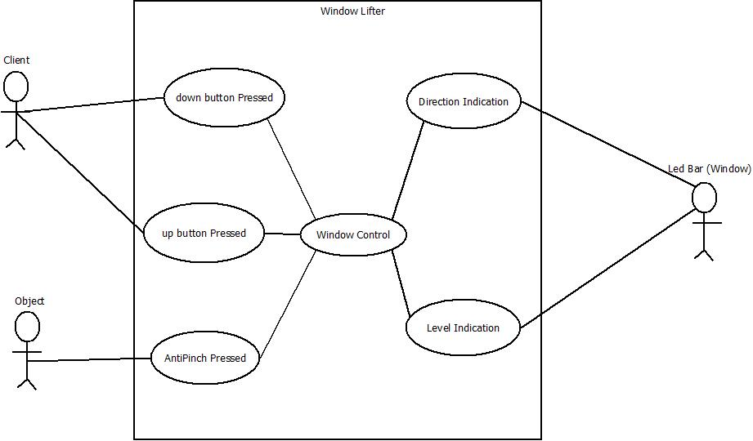

Client. The client is the application user. This client will press the buttons to start the window movement in any of the 2 possible directions.

Object. The object is considered as any item that could block the window movement when the window is closing. This object must have direct contact with a window to activate this entry.

Down Button Pressed. This use case represents when our system detects the user entry as an order to open the window (down movement).

Up Button Pressed. This use case represents when our system detects the user entry as an order to close the window (up movement).

Antipinch pressed. This use case represents when our system detects the user entry as an order to open the window as an emergency (down movement).

Window Control. This use case involves our main driver and functions that are part of our code.
This includes the window level computation, the direction manager and the indicator control.
In the next diagrams, this will be broken down into different components.

Direction Indication. This use case includes the direction indicator manager, depending on the user order entry, an indicator will be managed as an output. (The final actors will be leds. Green for opening, and blue for closing).

Level Indication. This includes our window level indicator manager that will be shown out at the end of the system (the ledbar that emulate the window).
Window (Ledbar). This is our very system end, a ledbar which will be turned on or off depending on the orders computed and explained previously.

4.2 Component Diagram
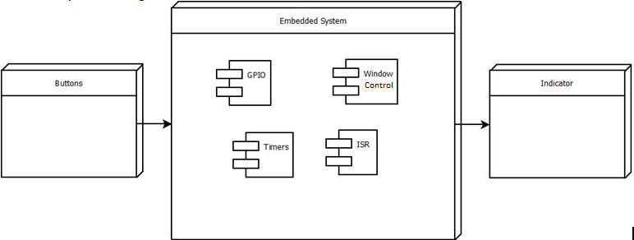
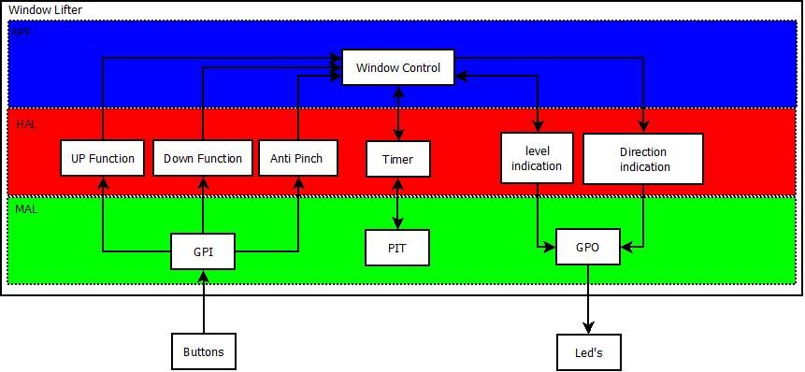

Embedded System.

Window Control. This is the main application, where the complete window control is saved . Based on the entry and the logical conditions within the application, our main application will send instructions to our actors.

GPIO. This component contains the input and output initialization and configuration to use the internal leds and buttons of our freescale microprocessor.
This also checks when a button is pressed and sends the output signal according to logical conditions.

Timers. This component involves the scheduler program. This component is configured to read the entries at a certain time periodically.

ISR. All internal interruptions are part of this component.

Buttons. Input components.

Indicator. Output components.

4.3 Design Diagram
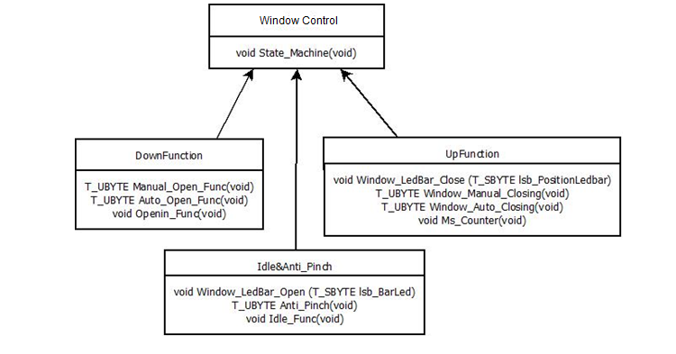

This diagram involves the 4 files used in the program, and its internal functions. These functions are described in detail below in part 5, functional decomposition.

4.5 Sequence Diagrams

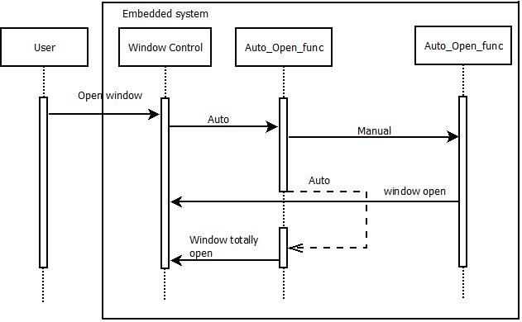

Open window. When the user presses a button for down function.
Auto. When the button is pressed and debounced.
Manual. When the button is pressed, debounced and the time the button is pressed is more than 500 ms.
Window open. When the window has been completely opened or the button is no longer pressed.
Window totally open. When the window has been completely open with the automatic function.

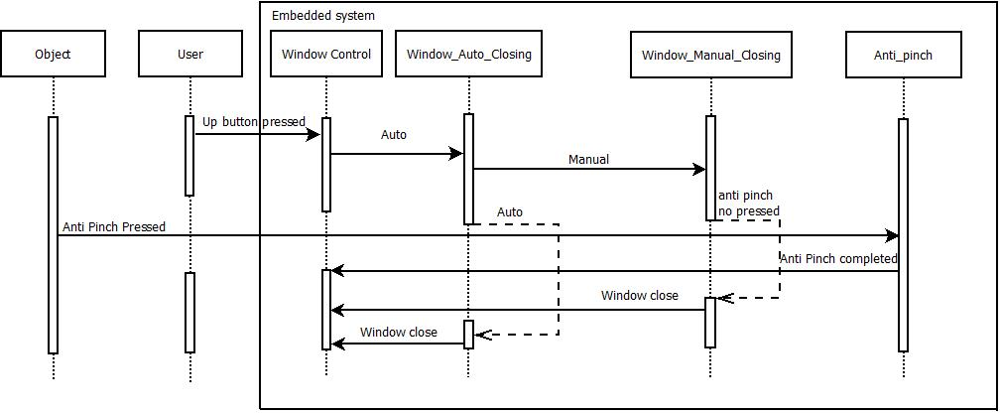
Up button pressed. When the user presses the button for up function (opening window).
Auto. When the button has been pressed and debounced.
Manual. When the button has been pressed, debounced and the time the button is pressed is more than 500 ms.
Antipinch no pressed. If the antipinch button is not pressed, the window continues the original movement (up/closing), either by the manual or auto function.
Antipinch pressed. When the antipinch button has been pressed and debounced.
Antipinch completed. When the antipinch function has completed it actions. (Opening window automatically, and waiting 5 seconds before restarting)
Window close. When the window has been completely closed or the button is no longer pressed.

SW Component internal breakdown
WindowLifter.c
WindowLifter.h
Idle&Anti_Pinch.c
Idle&Anti_Pinch.h
DownFunction.c
DownFunction.h
UpFunction.c
UpFunction.h

Functional Decomposition
5.1.1 State Machine Diagram
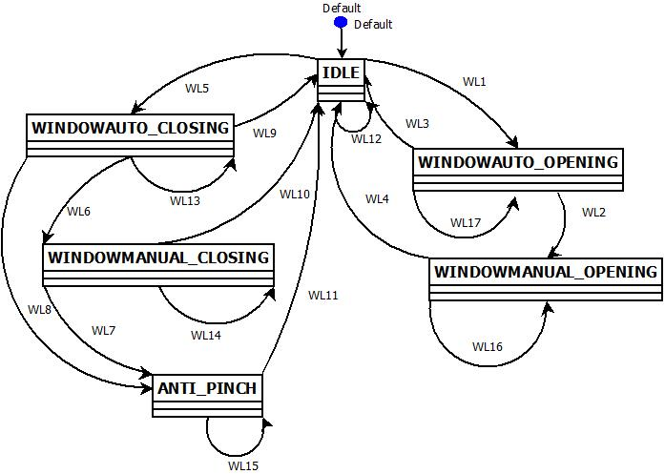

WL1. [Down Button==pressed && Timer> 10 ms && Timer< 500 ms] / (Window Auto Opening)
WL2. [Down Button==pressed && Timer> 500 ms] / (Window Manual Opening)
WL3. [Window ==open] / (Idle)
WL4. [Window==totally open || Down button== No pressed] / (Idle)
WL5. [Up Button==pressed && Timer> 10 ms] / (Window Auto Closing)
WL6. [Up Button ==pressed && Timer> 500 ms] / (Window Manual Closing)
WL7. [Antipinch button== pressed && Timer> 10 ms] / (AntiPinch)
WL8. [Antipinch button == pressed && Timer> 10ms] / (AntiPinch)
WL9. [Window ==totally closed] / (Idle)
WL10. [Window == totally closed || Up button == no pressed] / (Idle)
WL11. [Window == totally open && Timer> 5000 ms] / (Idle)
WL12. [Down Button == No pressed && Up Button == No pressed && Antipinch Button == No pressed] / (Idle)
WL13. [Window =! totally open] / (Window Auto Closing)
WL14. [Window =! totally open && button == pressed] / (Window Manual Closing)
WL15. [Window =! totally open && Timer> 5000 ms] / (AntiPinch)
WL16. [Window =! totally open && UP button == pressed] / (Window Manual Opening)
WL17. [Window =! totally open] / (Window Auto Opening)

Function Description and Dynamic Behavior
Provide detailed static and dynamic description of all functions of the SW Component.
Functions which are defined in other SW Components shall only be referenced in the external interface description!
The signature description shall be done inside the function header in the source code.
For each function, the following section should be copied

Function void STATE_MACHINE(void)

Description | This function is called periodically every 3.125 ms by scheduler, it contains our main state machine with all the possible states and its functions.
Parameter 1  <input| output| inout> | No parameters are used.
Parameter 2..n
Return Value | No return values
Precondition | Function will be called by the scheduler every 3.125 ms. PIT and scheduler has been initialized to provide the interruption at this given time.
Post condition | This function contains the state machine of our program. It keeps the value of the state in current use.
Error Conditions

Dynamic Behavior
State Chart¹, Flow Chart¹
5.1.1 State Machine Diagram

WL1. [Down Button==pressed && Timer> 10 ms && Timer< 500 ms] / (Window Auto Opening)
WL2. [Down Button==pressed && Timer> 500 ms] / (Window Manual Opening)
WL3. [Window ==open] / (Idle)
WL4. [Window==totally open || Down button== No pressed] / (Idle)
WL5. [Up Button==pressed && Timer> 10 ms] / (Window Auto Closing)
WL6. [Up Button ==pressed && Timer> 500 ms] / (Window Manual Closing)
WL7. [Antipinch button== pressed && Timer> 10 ms] / (AntiPinch)
WL8. [Antipinch button == pressed && Timer> 10ms] / (AntiPinch)
WL9. [Window ==totally closed] / (Idle)
WL10. [Window == totally closed || Up button == no pressed] / (Idle)
WL11. [Window == totally open && Timer> 5000 ms] / (Idle)
WL12. [Down Button == No pressed && Up Button == No pressed && Antipinch Button == No pressed] / (Idle)
WL13. [Window =! totally open] / (Window Auto Closing)
WL14. [Window =! totally open && button == pressed] / (Window Manual Closing)
WL15. [Window =! totally open && Timer> 5000 ms] / (AntiPinch)
WL16. [Window =! totally open && UP button == pressed] / (Window Manual Opening)
WL17. [Window =! totally open] / (Window Auto Opening)

Function Idle_Func ()
Description | Default state IDLE will call this function, which monitors if any button is pressed, to change the state accordingly.
Parameter 1  <input| output| inout> | None
Parameter 2..n
Return Value | None
Precondition | Function is called as default state machine function. IDLE
Post condition | Modify the machine state according to the button that is pressed.
Error Conditions

Dynamic Behavior

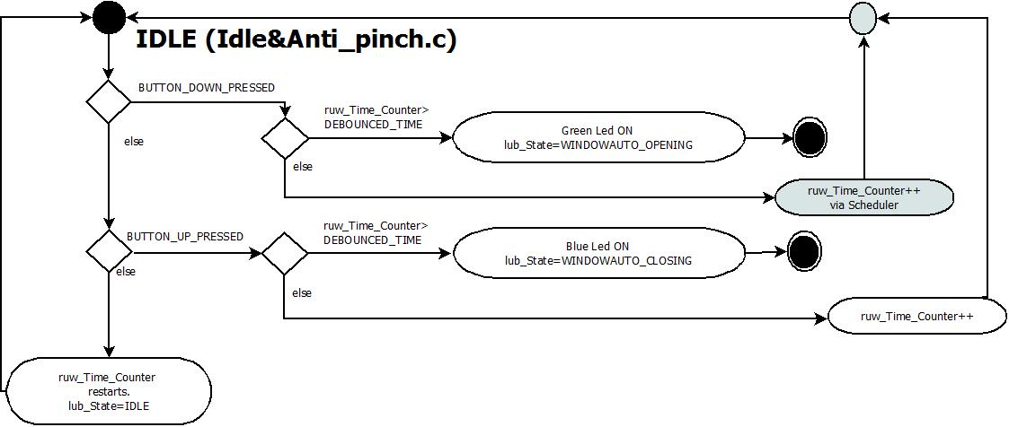

Function T_UBYTE Auto_Open_Func ()
Description | This function is called by the state machine, once the opening button is pressed and debounced and the state machine has been modified to Auto Opening This function monitors the time the button is being pressed, and can open the window automatically if the requirements are met, or will transfer the state to manual.
Parameter 1  <input| output| inout> | None
Parameter 2..n
Return Value | rub_State
Precondition | This function is called by the state machine, once the opening button is pressed and debounced.
Post condition | Modify the machine state according to the time the button is being pressed. If no longer pressed and window movement is complete, it will change the state to idle.
Error Conditions

Dynamic Behavior
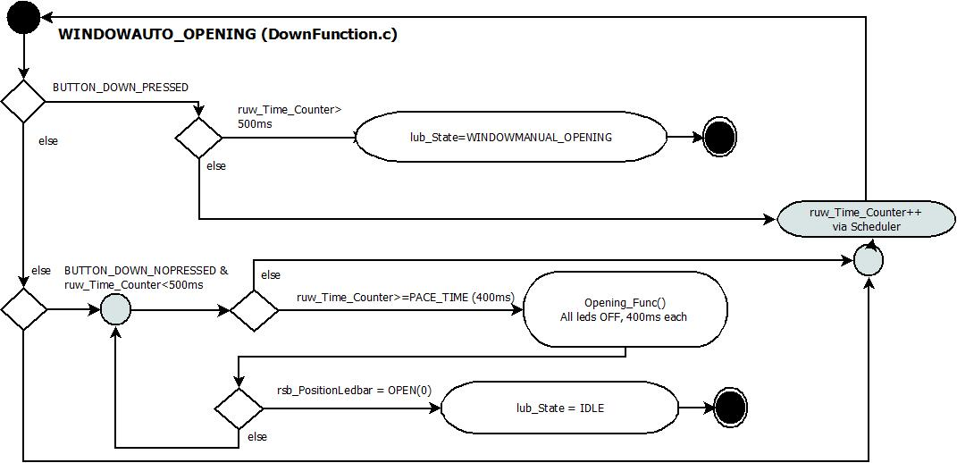

Function T_UBYTE Manual_Open_Func ()
Description | This function is called by the state machine, once the opening button is pressed and debounced, and the 500 ms requirement of button pressed is met. This function monitors if the button keeps being pressed to open the window . If the button is no longer being pressed, the state machine goes back to Idle.
Parameter 1  <input| output| inout> | None
Parameter 2..n
Return Value | rub_State
Precondition | This function is called by the state machine, once the opening button is pressed and debounced, and the button pressed time has overpassed 500ms.
Post condition | Modify the machine state according to the time the button is being pressed. If no longer pressed, it will change the state to idle.
Error Conditions

Dynamic Behavior

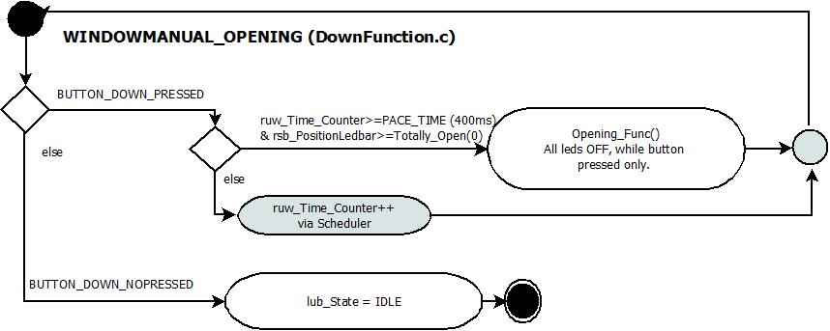

Function T_UBYTE Auto_Close_Func ()
Description | This function is called by the state machine, once the closing button is pressed and debounced and the state machine has been modified to Auto Closing. This function monitors the time the button is being pressed, and can close the window automatically if the requirements are met, or will transfer the state to manual. This function also monitors the antipinch button, if pressed, the state will change to antipinch state.
Parameter 1  <input| output| inout> | None
Parameter 2..n
Return Value | rub_State
Precondition | This function is called by the state machine, once the closing button is pressed and debounced.
Post condition | Modify the machine state according to the time the button is being pressed. If no longer pressed and window movement is complete, it will change the state to idle.
Error Conditions

Dynamic Behavior
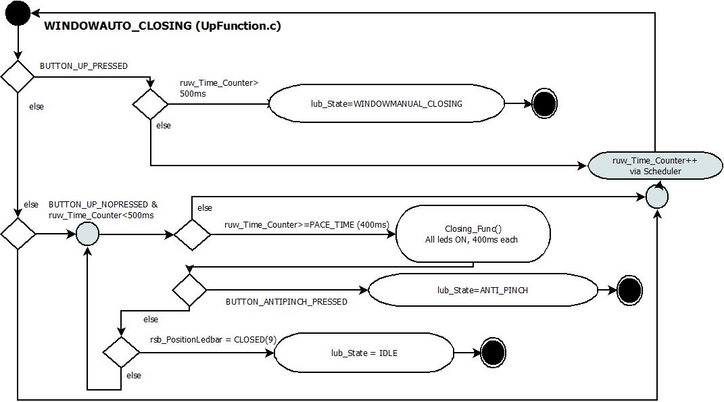

Function T_UBYTE Manual_Close_Func ()
Description | This function is called by the state machine, once the closing button is pressed and debounced, and the 500 ms requirement of button pressed is met. This function monitors if the button keeps being pressed to close the window . If the button is no longer being pressed, the state machine goes back to Idle.  This function also monitors the antipinch button, if pressed, the state will change to antipinch state.
Parameter 1  <input| output| inout> | None
Parameter 2..n
Return Value | rub_State
Precondition | This function is called by the state machine, once the closing button is pressed and debounced, and the button pressed time has overpassed 500ms.
Post condition | Modify the machine state according to the time the button is being pressed. If no longer pressed, it will change the state to idle.
Error Conditions

Dynamic Behavior

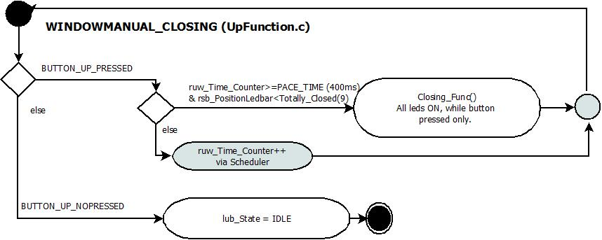

Function T_UBYTE Antipinch_Func ()
Description | This function is called by the state machine, once the antipinch button is pressed, debounced and the window is closing. This function opens the window automatically and once open, it stops the program for 5 seconds. Then returns to idle
Parameter 1  <input| output| inout> | None
Parameter 2..n
Return Value | rub_State
Precondition | This function is called by the state machine, once the antipinch button is pressed and debounced, and the window is closing.
Post condition | The window will now be completely open, the program will stop for 5 seconds and the machine state will be modified to idle at the end.
Error Conditions

Dynamic Behavior
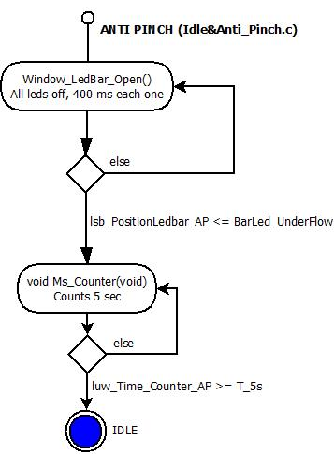

Function opening_func ()
Description | Emulates opening Window, turning off leds.
Parameter 1  <input| output| inout> | None
Parameter 2..n
Return Value | None
Precondition | Functions is called when the button up is pressed, and the time button press requirements have been met. It may be called either by the manual or the auto mode function.
Post condition | This function modifies the led counter, so the machine state keeps on working based on the new value.
Error Conditions

Dynamic Behavior
State Chart¹, Flow Chart¹, Nassi Shneiderman
¹ Preferred
This functions received the signal of button validation, and depending on the time the push button is pressed, our leds will turn off to emulate the window is opening.

Function closing_func ()
Description | Emulates closing Window, turning on leds.
Parameter 1  <input| output| inout> | None
Parameter 2..n
Return Value | None
Precondition | Functions is called when the button down is pressed , (or at certain point, the anti-pinch button) and the button press requirements have been met. It may be called either by the manual or the auto mode function.
Post condition | This function modifies the led counter, so the machine state keeps on working based on the new value.
Error Conditions

Dynamic Behavior
State Chart¹, Flow Chart¹, Nassi Shneiderman
¹ Preferred
This functions received the signal of button validation, and depending on the time the push button is pressed, our leds will turn on to emulate the window is closing.

Function main ()
Description | GPIOs and scheduler initialization
Parameter 1  <input| output| inout> | None
Parameter 2..n
Return Value | None
Precondition | Functions is called as a main function once the program starts
Post condition
Error Conditions

Dynamic Behavior
State Chart¹, Flow Chart¹, Nassi Shneiderman

